Sethatevy Bong

CMSC 203

Assignment 2 – Design

Due: 02/25/2020

**Psuedocode**

1. Program starts
2. Display a welcome message “Welcome to the Toy Company to choose gifts for young children.”
3. Print prompt to ask for the name of the child
4. Receive input for the name of the child and store in a variable “childName”
5. Print prompt to ask for the age of the child
6. Receive input for the age of the child and store in a variable “childAge”
7. Print prompt user for toy choice and store the input in variable “ToyChoice”
8. Validate the input by a while loop
   1. While toyChoice != plushie, block, or book,
   2. Display error message "Invalid choice, please choose again", ask for new input
9. Call ageOK to test if gift is age appropriate
10. If gift is not appropriate for age, repeat question until appropriate gift is chosen
11. Prompt user to ask if card is included (yes or no) and store in String cardChoice
    1. If yes, call addCard
    2. If no, continue
12. Prompt and ask if balloon will be included (yes or no) and store in balloonChoice
    1. If yes, call addBalloon and addCost
    2. If no, continue
13. Prompt user if another toy will be ordered
    1. If yes, repeat 3-13
    2. If no, continue
14. Add cost of each gift to total
15. Prices found in Toy.java
16. Generate a random five-digit order number
17. Display order summary, total, and order number to user
18. Call toString method
19. Print programmer's information and program end

Link to GitHub files

<https://github.com/Tevy-B/CMSC-203_Assignment-2_-Tevy>

Test Plan

|  |  |  |  |  |
| --- | --- | --- | --- | --- |
| Test Case # | Input | Expected Output | Actual Output | Did the test pass? |
| 1 | Name: Lucy Laker  Age: 2  Toy: plushie  Card: no  Balloon: no Another toy? yes Name: Dan Smith Age: 5  Toy: blocks  Card: no  Balloon: no Another toy? no | BIRTHDAY GIFTS  The gift for Lucy Laker at 2 years old is a plushie for $25.00  The gift for Dan Smith at 5 years old is blocks for $20.00  The total cost of your order is $45.00  Order number is [random number]  Programmer: Sethatevy Bong | Welcome to the Toy Company to choose gifts for young children  The gift for Lucy Laker at 2 years old is a plushie for $25.00  The gift for Dan Smith at 5 years old is blocks for $20.00  The total cost of your order is $45.00  Order number is 2369  Programmer: Sethatevy Bong | yes |
| 2 | Name: Tony Sak  Age: 2  Toy: plushie  Card: no  Balloon: yes Another toy? no | BIRTHDAY GIFTS  The gift for Tony Sak at 2 years old is a plushie for $31.00  The total cost of your order is $31.00  Order number is [random number]  Programmer: Sethatevy Bong | Welcome to the Toy Company to choose gifts for young children  The gift for Tony Sak at 2 years old is a plushie for $31.00  The total cost of your order is $31.00  Order number is [random number]  Programmer: Sethatevy Bong | yes |
| 3 | Name: Wendy Lum  Age: 3  Toy: books  Different toy? No  Card: yes  Balloon: yes  Another toy? no | BIRTHDAY GIFTS  Toy is not age-appropriate  Do you want a different toy? Yes or No  The gift for Wendy Lum at 2 years old is a book for $23.95  The total cost of your order is $23.95  Order number is [random number]  Programmer: Sethatevy Bong | Welcome to the Toy Company to choose gifts for young children  Toy is not age-appropriate  Do you want a different toy? Yes or No  The gift for Wendy Lum at 2 years old is a book for $23.95  The total cost of your order is $23.95  Order number is 7613  Programmer: Sethatevy Bong | yes |
| 4 | Name: Issac Gotka  Age: 3  Toy: blocks  Card: yes  Balloon: yes  Another toy? Yes  Name: John Blakely  Age: 2  Toy: blocks  Different toy? No  Card: no  Balloon: yes Another toy? no | BIRTHDAY GIFTS  The gift for Issac Gotka at 3 years old is blocks for $28.95  Toy is not age-appropriate  Do you want a different toy? Yes or No  The gift for John Blakely at 2 years old is blocks for $26.00  The total cost of your order is $54.95  Order number is [random number]  Programmer: Sethatevy Bong | Welcome to the Toy Company to choose gifts for young children  The gift for Issac Gotka at 2 years old is blocks for $28.95  Toy is not age-appropriate  Do you want a different toy? Yes or No  The gift for John Blakely at 2 years old is blocks for $26.00  The total cost of your order is $54.95  Order number is 3439  Programmer: Sethatevy Bong | yes |

TEST#1 OUTPUT

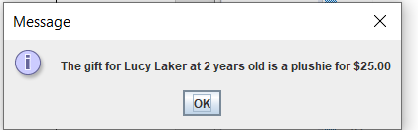

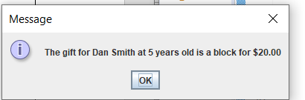

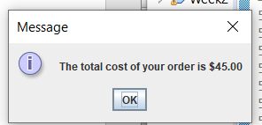

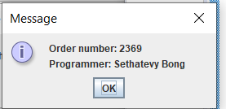

TEST#2 OUTPUT

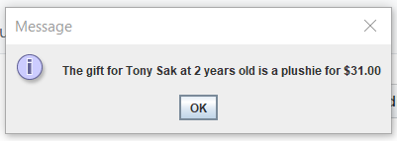

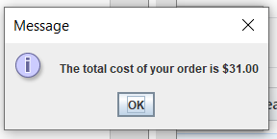

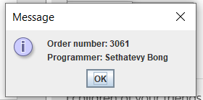

TEST#3 OUTPUT

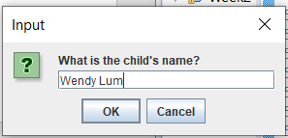

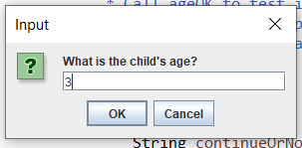

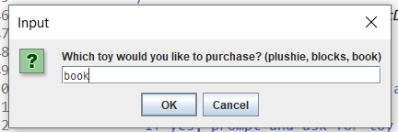

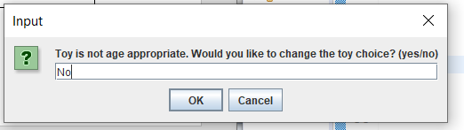

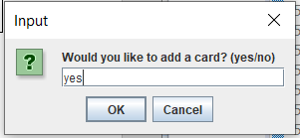

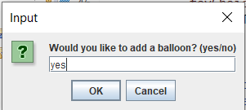

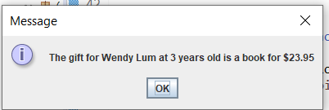

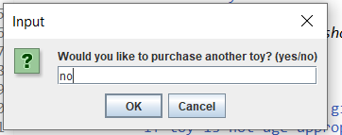

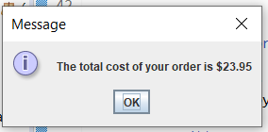

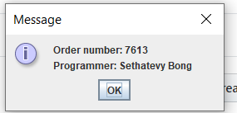

TEST#4 OUTPUT

